3 Postman with Soap

This section will guide you to:

* Use Postman with SOAP

**Development Environment:**

* Postman Tool
* Endpoint URL

This guide has three subsections, namely:

2.3.1 Adding SOAP request in postman

2.3.2 Running and validating the response

2.3.3 Pushing the code to your GitHub repositories

**Step 2.3.1:** Adding SOAP request in Postman

* The screenshot below shows the Postman Workspace.

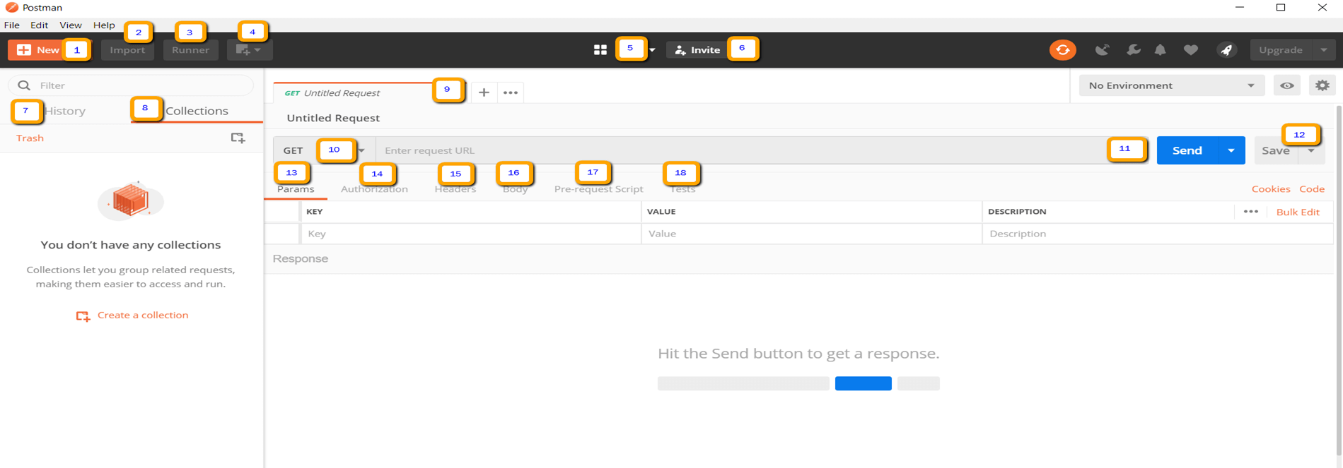

* Open Postman WorkSpace.
* On the top left corner, click on the **New option** button.

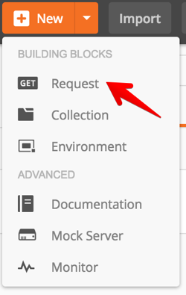

* In the drop-down options available, click on the Request option.
* Your Request is ready now.
* Take the given URL as the Soap request URL.

<http://webservices.oorsprong.org/websamples.countryinfo/CountryInfoService.wso?WSDL>

* In the request URL field, input the above link.
* Then set the method as Post.
* Set Body as raw and set text as XML.
* Provide data in the body.

<Envelope xmlns="http:**//**schemas.xmlsoap.org/soap/envelope/">

• <Body>

• <CapitalCity xmlns="http:**//**www.oorsprong.org/websamples.countryinfo">

• <sCountryISOCode>IN</sCountryISOCode>

• </CapitalCity>

• </Body>

• </Envelope>

* **IN** keyword in the above code block is the Country code for India.
* Click on the Send.

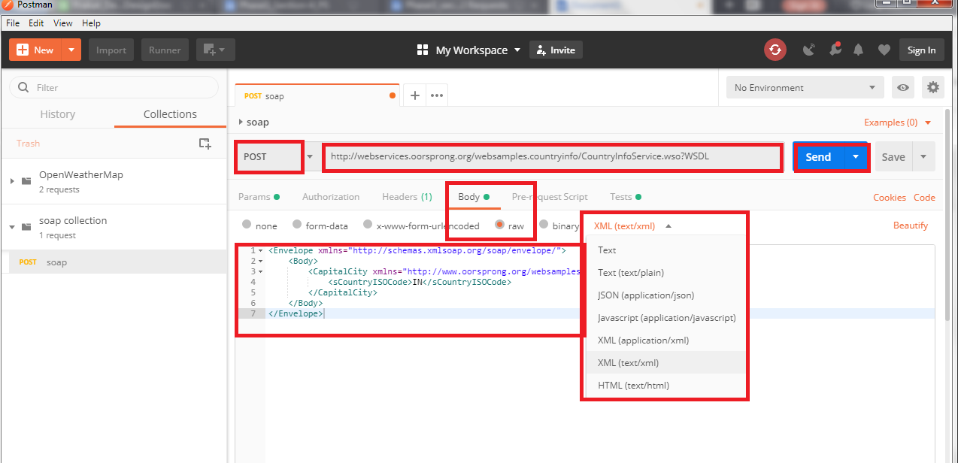

* Scroll down and click on the Body and verify the Response.

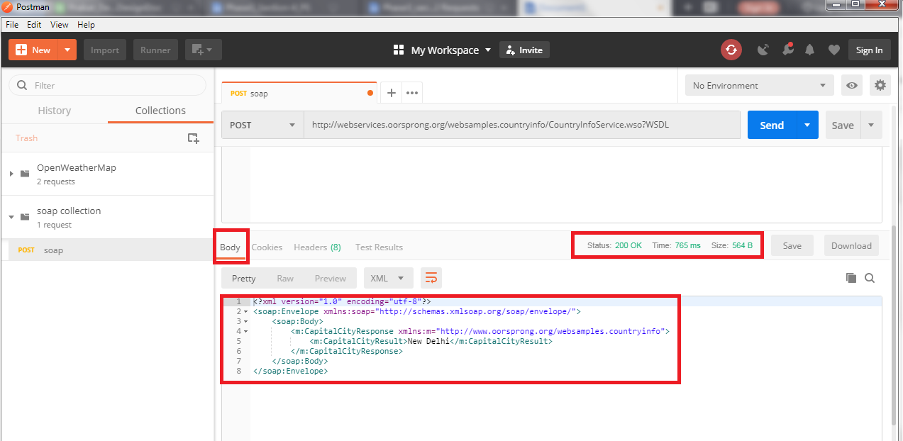

**Step 2.3.2:** Running and validating the response

* Click on Tests.
* Select Status code: Code is 200
* Click on Send again.

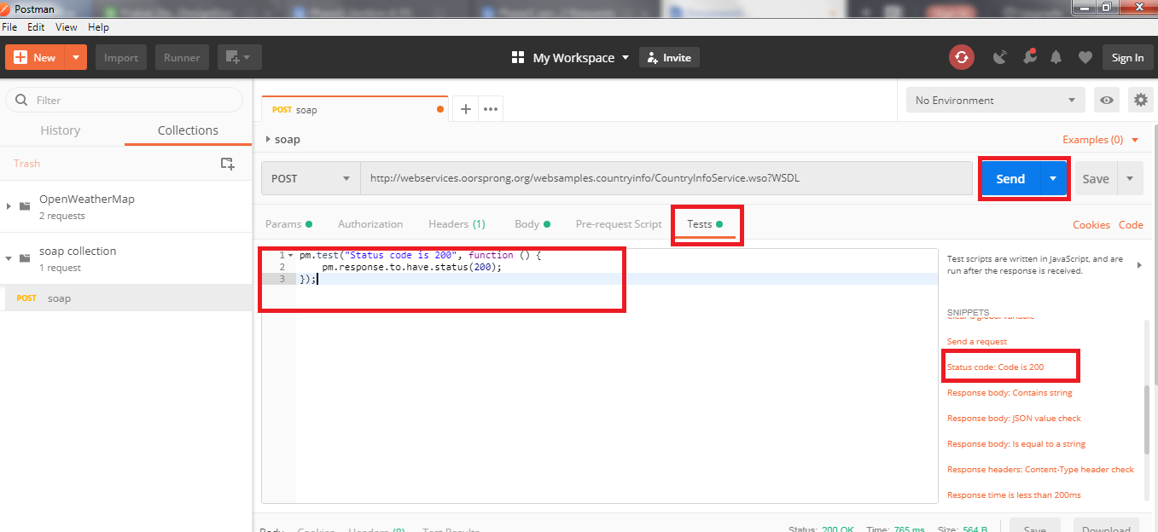

* Scroll down and click on TestResults and verify the response.

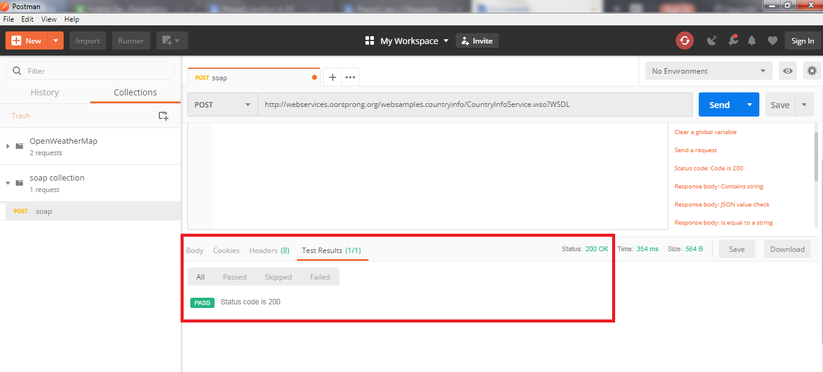

* You will see 200 OK Messages.

**Step 2.3.3:** Pushing the code to your GitHub repositories.

Open your command prompt and navigate to the folder where you have created your files.

cd <folder path>

Initialize your repository using the following command:

git init

Add all the files to your git repository using the following command:

git add . 

Commit the changes using the following command:

git commit . -m “Changes have been committed.”

Push the files to the folder you initially created using the following command:

git push -u origin master